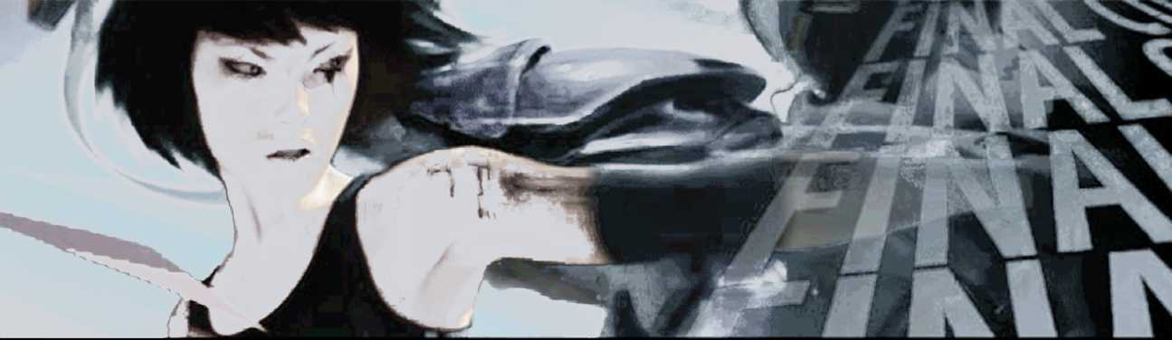
I
f you suffer from vertigo, prepare to conquer your fears...
Mirror's fdgegameplay is all about cheating gravity with a
Parkour-inspired, non-stop, high-flying, death-defying
athleticism. Haring around roof-tops, scaling walls,
body flinging from ledge to high-wire, the player
experiences a profoundly effective sense of movement and
perspective as they take the role of Faith, a 'runner'.
Her underground, outlawed courier role is the only
communication vehicle of privacy within an oppressive
government-controlled future cityscape.
For Audio Director Magnus Walterstad, the primary challenge was to create audio playback logic seamlessly delivering Foley and breathing sound FX content interactively, never 'breaking the spell', no matter how outlandish the stunts a player might attempt in a game-world of open-ended acrobatic opportunities.
word being perception. Most of the environmental sound sources in the game would be set up by using the game engine editor, allowing Walterstad to define 'point emitters' in 3D geometry at specific x, y, and z positions, and assign them sounds to be played back under certain logical conditions e.g., the proximity of the player, time of day, and so on. But it was clear the resulting relatively literal live mix created by the game engine would have to be significantly overridden at run-time to realise Walterstad's manifesto.

Still Movement
'I figured that if you stand still in the game you should have a sense of this mass of city sound constantly changing and developing (without of course ever repeating - a challenge in itself). If you were to start walking, I didn't aiitfciiiiMfcitaaaaiaiifcafciiaiiMMtfattflMtatitfiiiiitti
'momentum, thecitys<jR| sound yyOuld slowly^TC TQ^mh«Vnce the sepsegjf speed there would be less go Ambience,.more of yoti^own hojoy, .md^n'ow svv as you rush by spec In • [) positfomKl audio obje kind of like wtfen;yoQ run-or cycle harcfear^ou gel a kind of sound bubble* it's vou and .cur sound?
As with so many videogame productions, however, the final course of the game was only established after a significant period of experimentation, as Walterstad explains: “The project has shifted quite a bit for sure. Originally we had a male lead character and there were tons of weapons - obviously an initial focus for sound. However, it's morphed through various versions to become a first-person action adventure game with the focus definitely not on guns! In the end, we really didn't want the traditional floating camera view with gun dangling - we wanted full immersion and interaction with the environment. So it's all about agility - how you move from A to B using the most efficient route - without getting killed."
Once Mirror's Edge direction was determined some two yrs ago. Walterstad (whose previous foray into gaming was the renowned Battlefield 1942) crystallised his vision for the title's audio by literally writing down a 'manifesto' describing what theplayer would hear during four minutes of gameplay. His aim was to define how the game's sound should reflect what he believed would be Faith's sonic perception of the world - the operative
breathing in the zone - the air whooshing by and even the sound of your own clothes flapping. The other dimension to Mirror's Edge audio is that same bubble being burst by enemy gunfire whereupon I wanted the overall sound to become stressful and unpleasant.”
For proof of concept. Walterstad prototyped his ideas by dubbing linear video of early stage game footage, the results of which are made public at http://gamevideos.1up. com/video/id/21561. He then liaised with the technical team re-designing some aspects of the existing sound 'engine': 'I tend to think the same way I mix on a board - bussing channels together and so on - and that's similar to how the sound engine worked with definition of'sound groups'. But we also added the concept of'mix groups' too, so that by setting software flags in the game and triggering the use of different mix groups of sound according to overall game conditions, e.g., the player is running but not under threat • we could select the appropriate set of sounds to play at any given moment. We could even create the illusion of a ducking side-chain signal path where a player's hard landing from a big jump might appear to duck and filter the rest of the sound replay momentarily. All of this control was vital to deliver the dynamic and fully interactive sound mix I was after without having to
John Broomhall talks with DICE'S Magnus Walterstad about cheating gravity from the rooftops, walking on glass, and death falls in Mirror's Edge, a game that brings a whole new meaning to realistic sound effects.
24
AUDIO MEDIA JANUARY 2009
