Hi there, this doc will explain how to open and use the “hidden” editor for Mirror’s Edge.
This editor is basically just UDK (Unreal engine 3) that is enabled through some files that we manually add to the game. It’s a little lengthy, but will help you get onto making your own custom maps!

You will need a couple of things installed/files in order for this to work:

Mirror’s Edge installed
wxRC and wxRes folders which can be found in Unreal Tournament 3 for PC

If you do not have access to these files I’m looking at providing them on a web host for everyone to use :) for more info, or if you need imediate access to them, feel free to pm me on reddit: www.reddit.com/u/skyblaster109

Step1: Opening the editor

First thing you'll want to do is go to your Mirrors Edge installation directory which by default is C:/Program Files/EA Games/Mirror’s Edge
This directory can be different depending on where you installed the game.

Enter the Binaries folder, then right click the MirrorsEdge.exe and create a shortcut.
Next, right click - properties on the shortcut, where it says Target: add in the word “editor” without the quotes. Like in this screenshot:
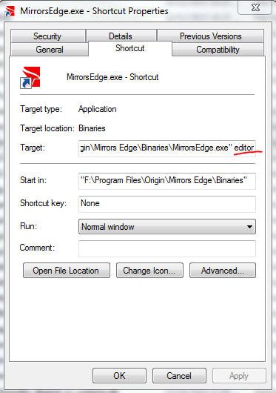

Next thing to do is copy over the wxRC and wxRes folders into the Mirror’s Edge Binaries folder like so:
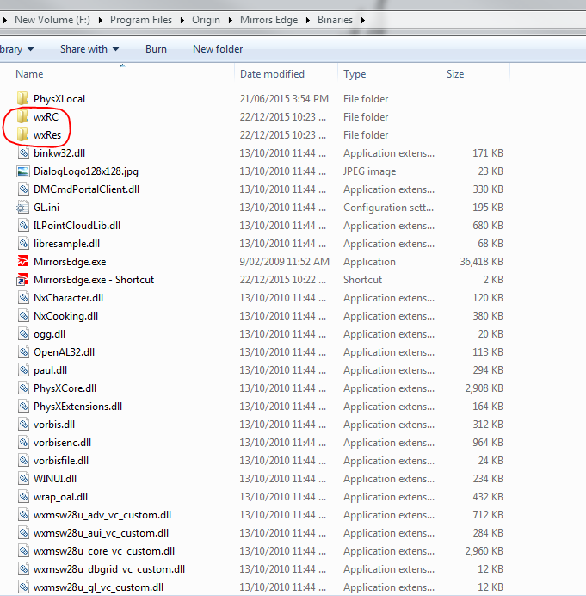

And that’s it!
The editor should now open when the shortcut is run!
Step 2: Using the Editor

This section should hopefully put people in the right track in messing around/creating maps with the Mirror’s Edge editor. Please keep in mind this tutorial is not a UDK tutorial. There are plenty of those on the internet already, this is aimed at getting the Mirror’s Edge editor to work.

IMPORTANT!!!!
Because of limitations to the editor there are a few things to take note of before jumping into the editor.
Please make sure you follow these steps to avoid any trouble. As with any modding or altering of game files. Make sure you have a backup just in case

First up, you will want to create the Published and Unpublished folders because you do NOT want to overwrite the original files.

Go to: My Documents/EA Games/Mirror’s Edge/TdGame

And create 2 folders called Published and Unpublished. Then inside those new folders create a CookedPC folder, then inside that a Maps folder. So your folder structure should now be:
Documents/EA Games/Mirror’s Edge/TdGame/Published/CookedPC/Maps
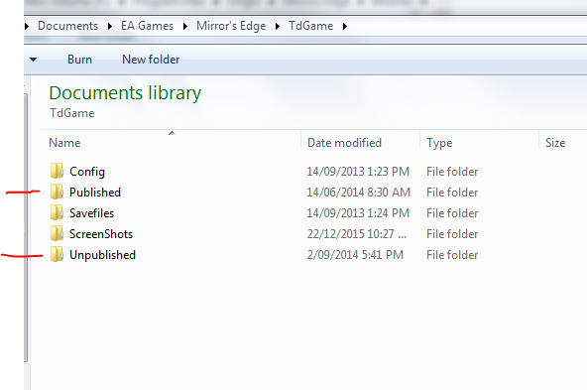

Do the same thing for the Unpublished folder. The reason for this is when you run the game, and there is a file with the same name in the Published folder as in the installation directory, the game will load the one from Published first. For example say the game loads “Tutorial1” as a map, and we create our own environment, and put it in the Published folder with the name “Tutorial1” the game will then load our version of the map, and technically we can just remove that folder and the old map will load again.

The editor works in the same way, but with a Unpublished folder instead.

This next part can be a little tricky at first. When saving the maps inside the editor. You have to save them with the same name as the original maps, otherwise the editor won’t be able to open them back up. This is a list of the map names used by the game
http://unrealedge.wikia.com/wiki/Map_Name_Reference
The editor will only look for the file in the Unpublished folder, and if it can’t find it, it will simply load the original files, so you must always save (or copy) the map to the Unpublished directory we set up in the My Documents.

Now that all the tricky business is out the way, let’s begin using the editor!

Moving the 3d view port: Right click and hold lets you rotate the camera. Scroll wheel zooms in and out. Holding right click then left click allows you to raise and lower the camera. Unlike other UDK or Unreal engine editors, the Right click - WASD movement doesn’t seem to work in this editor

When you open the editor you’ll be greeted with 3 pop ups. The first being a Error message, a “Tip of the day” and the Content Browser. For now close all 3.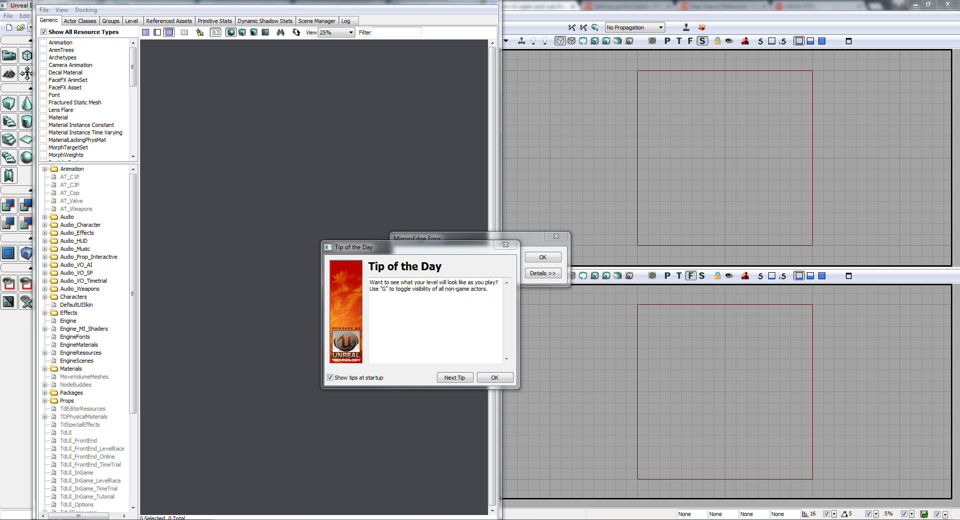

Now at first you will be greeted with the editor in all its glory. It seems overwhelming at first. But here’s a quick way to get a empty room, light and a player.

First up: Right click the cube on the left side of the screen. Then change the values for XYZ to 1000 and check the box that says “hollow” Then click Build and close that window.
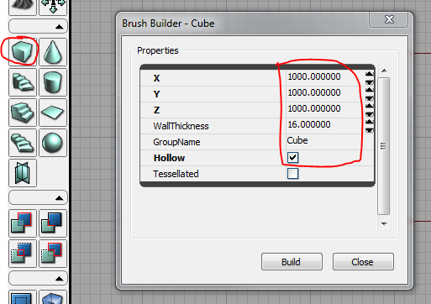

Think of the world as empty space. So you can either add to it, or subtract things away. By default the world starts off as empty, so we have to fill it. To do that click the CSG: Add button:
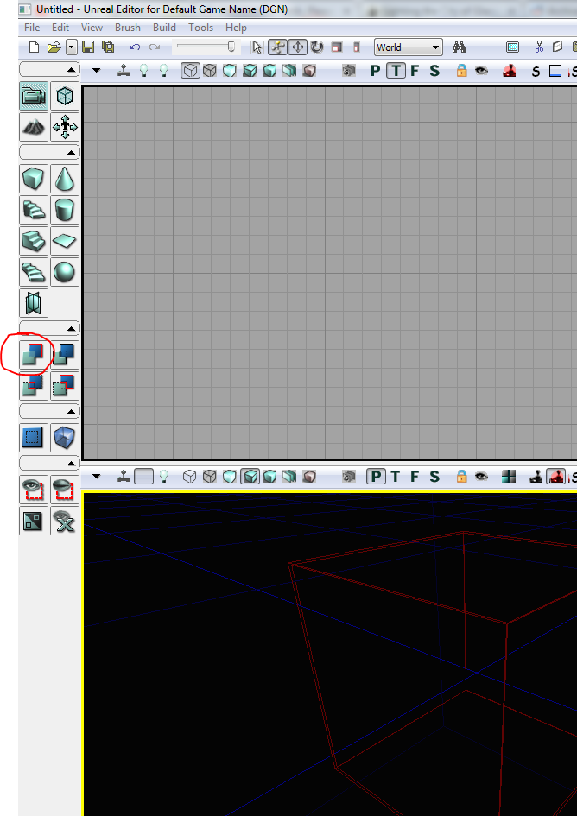

Looks like nothing happened right? Almost. Zoom in to the cube in the 3d view by right clicking the window to activate it, then mouse scrolling until you are inside the cube like this:
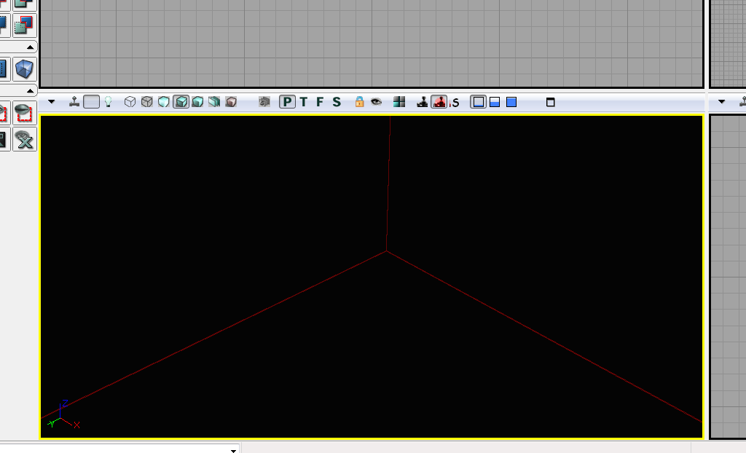
Then right click - add actor - add light. Then using the XYZ axis, move the light to be inside the room

Okay so we have a room, but how do we run around in it? We need somewhere for the player to start, so again
Right click - add actor - add PlayerStart

One more thing to do before we try out the room level. Up the top in the menu’s, select Build - Lighting. Click okay, then close on the error window that shows up once it’s done.

Now right clicking on the floor and selecting “Play from here” will open up a play window!
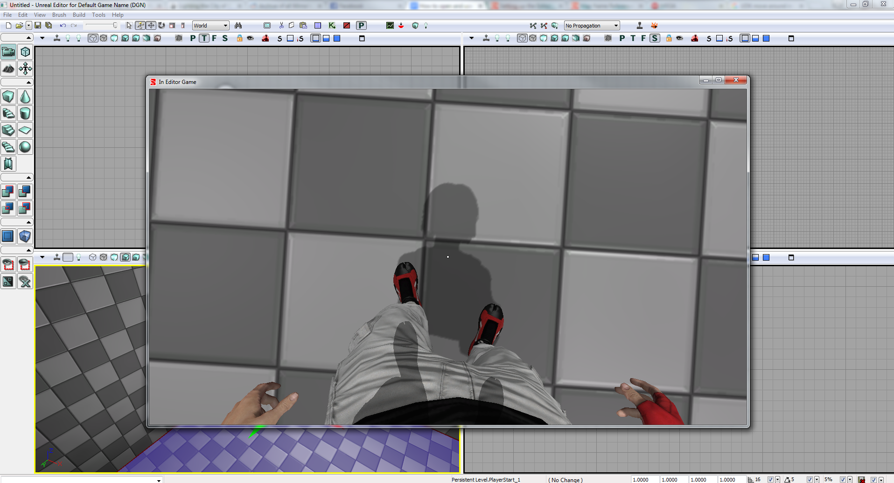

Unfortunately there are some issues with this play window. Jumping can cause you to die, sometimes Faith will just randomly die after certain periods of time, there are no sounds for punching plus some other slightly annoying aspects. But all basic movements are already there just like the game :)

Content Browser
This plays an important role in any Unreal engine editors. It basically has all the assets needed in the game. Including textures, materials, level props, physic materials etc.

The content browser can be opened by clicking this button in the top menu:
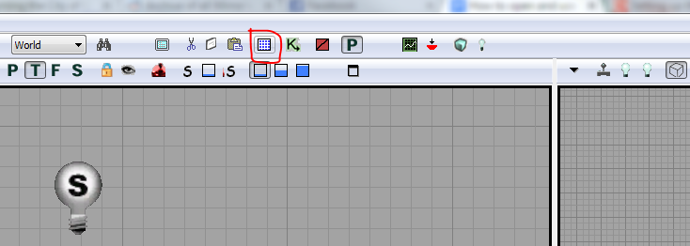

This is where you can find textures and props. Props and models will be outlined in blue, materials green, rigs/skeletons purple and textures in red.
Select the bag model in the content browser, then in the scene
Right click - add actor - add static mesh static bag. This will place it into the scene. You can do this for any model in the content browser.
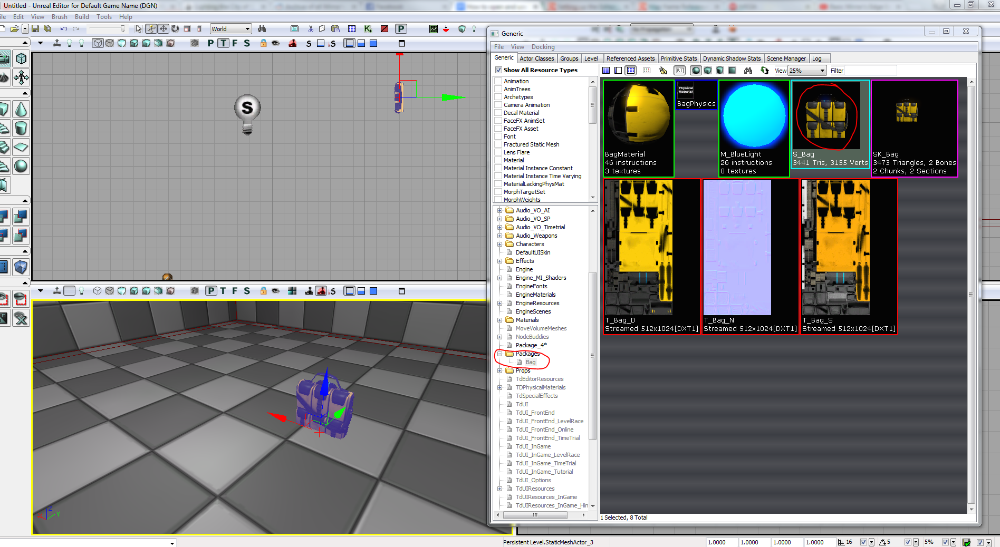

A similar method is used to apply textures to objects in the world. In this example we have to load in some more textures from the game. To do this, in the Content browser window, click File - open
Then browse to where the game is installed
(default is C:/Program Files/EA Games/Mirror’s Edge)
Then go into the TdGame - CookedPC - Materials and for this example. Ill open the M_ads.upk

Now, select the texture, then left click a wall in the 3d view, it should turn purple. Then right click the wall and select “apply material”
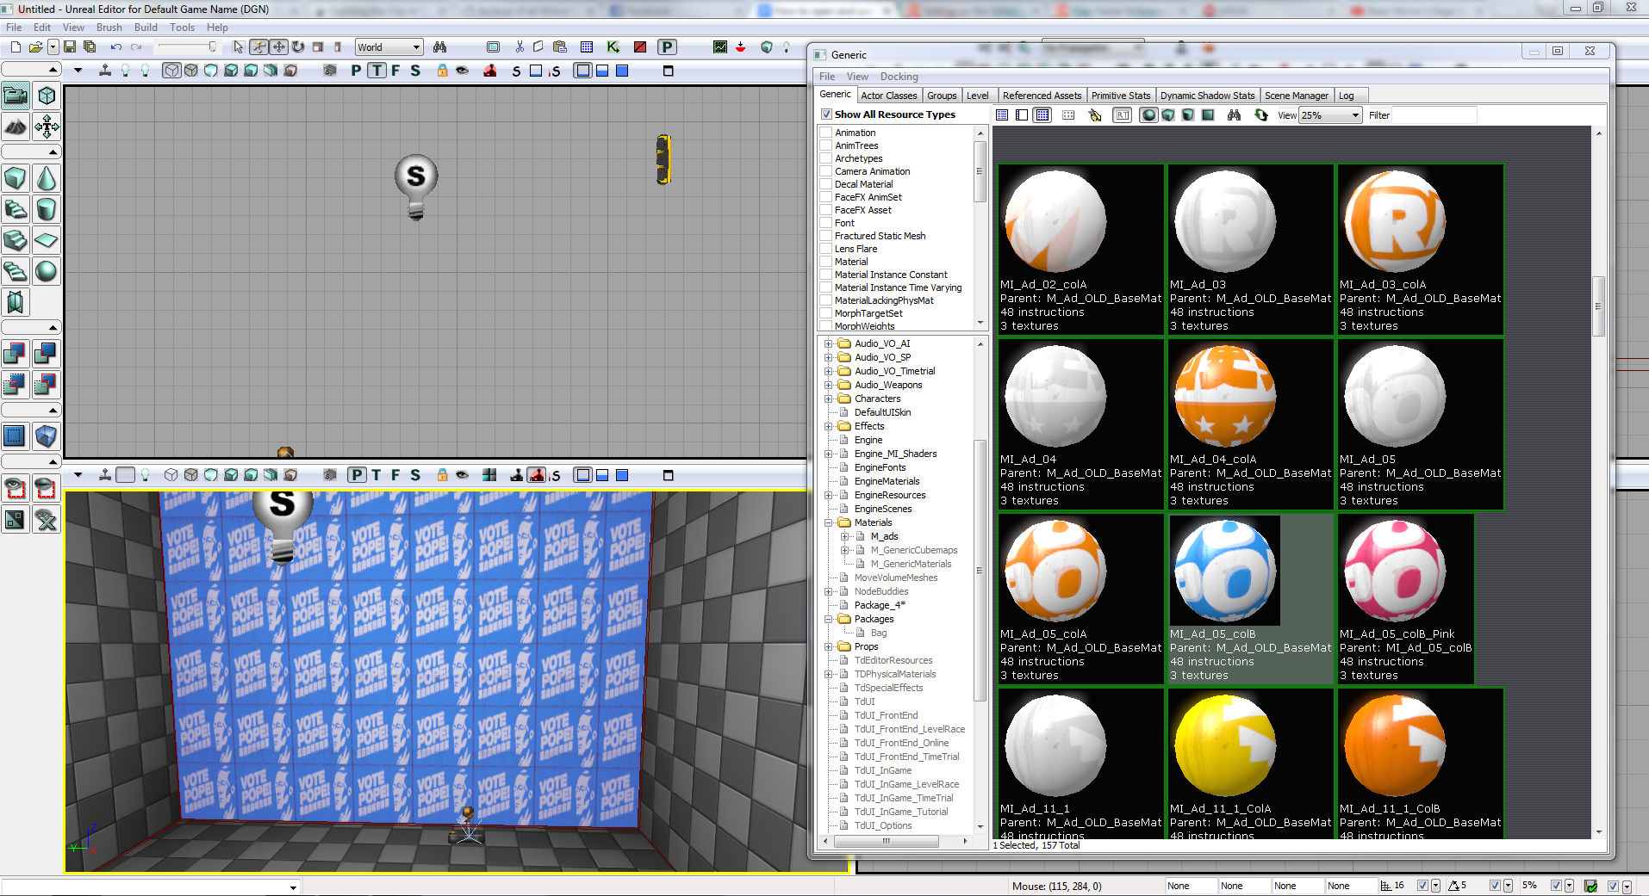

You can then fix the alignment by right clicking the same wall - Alignment - Fit

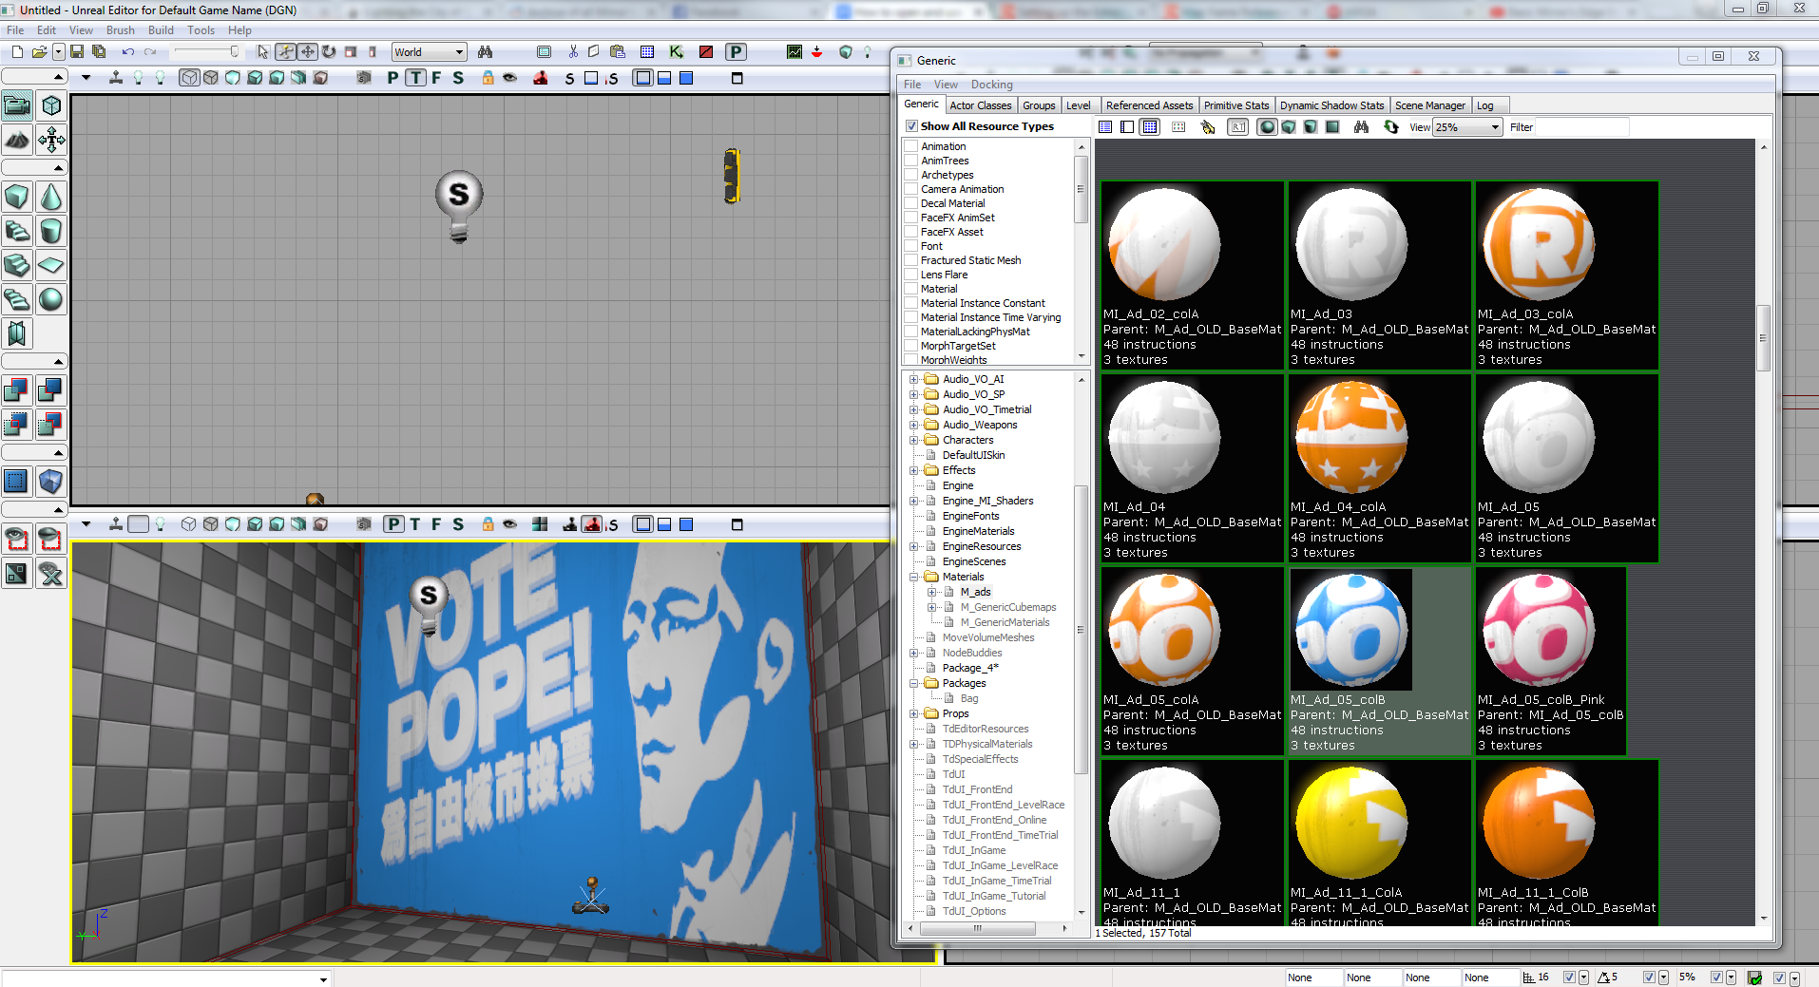

Here is a quick scene with some props and texture changes. This is just a very basic tutorial, please pm me at www.reddit.com/u/skyblaster109 if you’d like to know how to add in objects from the game such as the vaulting/jump box

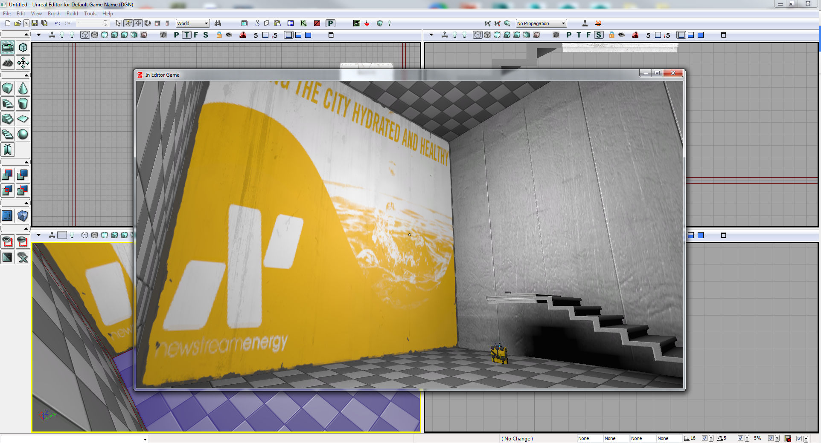

Hope this helps anyone who wants to start making Mirror’s Edge maps!

*Disclaimer - editing Google docs is not really my strong point, hopefully this is formatted so it’s not too hard to read/see the images

